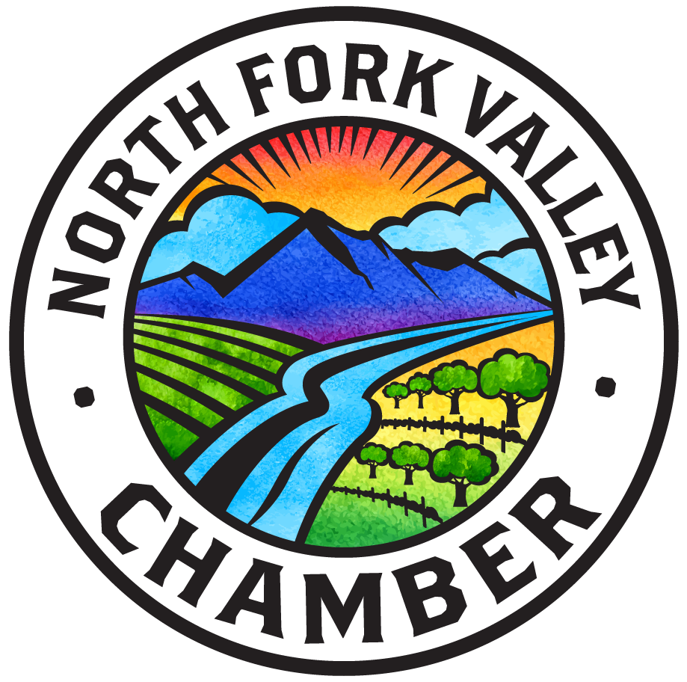

**2026 Membership Application**

**Business/Organization Name**: _________________________________________________________________________

**Physical Address:** ___________________________________________________________________________________

**Mailing** (if different): ___________________________________________________________________________________

**Contact person:** ___________________________________________ **Phone:** ________________________________

**Email Address:** ________________________________________ **Website:** www.______________________________

**100-word description for Business Directory** (or email logo or JPEG photo & description to: *nfvchamber@gmail.com)*

__________________________________________________________________________________________________

__________________________________________________________________________________________________

__________________________________________________________________________________________________

__________________________________________________________________________________________________





**Membership Category:** □ Business $100 □ Non-profit $50 □ 2nd Business +$50

□ Check here to be contacted when the Chamber needs event volunteers.

□ Check here to volunteer to lead a mentoring workshop.

□ Check here if you are a new member. Do you want a ribbon cutting? □ Yes □ No

□ Check here to get a window cling to advertise your membership at your business.

**Where should the Chamber focus its energy? Constructive feedback is always welcome**!

__________________________________________________________________________________________________

__________________________________________________________________________________________________

***Checks may be made out and mailed to: North Fork Valley Chamber, PO Box 158, Hotchkiss, CO 81419***